Name and Surname | Control  STULWANE |  | Trial  STULWANE | %Cover (at planting) | % Weeds (0%) – high weed infestation – to (100%) no weeds, |  | % pests (0%) bad- (100%) – |  | % growth (germination, colour, height, health) | Overall score (10) | Harvest figures  Beans (1-2.5 t /ha)  Cowpea (1-1.2 t /ha)  Maize  (4-10 t/ha)
STULWANE
1. Dlezakhe Hlongwane  28°55.724´S  29°22.207´E |  | 66x55m=3685m². Ploughed and planted with oxen. Maxiphos (36) 1x50kg and 100kg of Manure. Traditional maize. 66rowsx144plnts/row. Used roundup pre plant and decis forte at planting | 800m². Hand hoe plots only. 400m² intercrop. Rest planted in blocks. 25kg MAP, 25 kg LAN- top dressing. Tested the matracca, but found the soil very hard. Roundup pre and at planting. Dual Gold and decis forte at planting. | 15%- dead weeds,  5% | 90%  Very few weeds, good crop cover  60% |  | 90%  90% |  | 90%  90% | 7.1  Trial  6.41 control | Beans  900 kg/ ha  Cowpea:  750  Kg/ha
 |  | 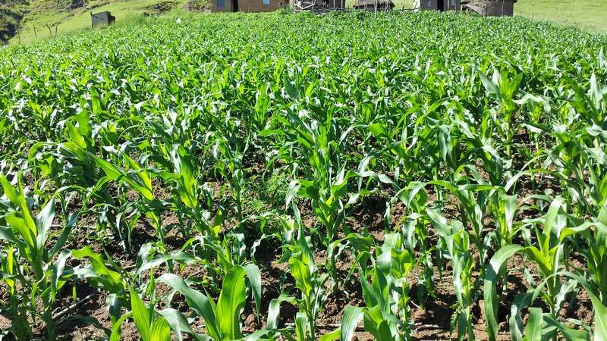 | 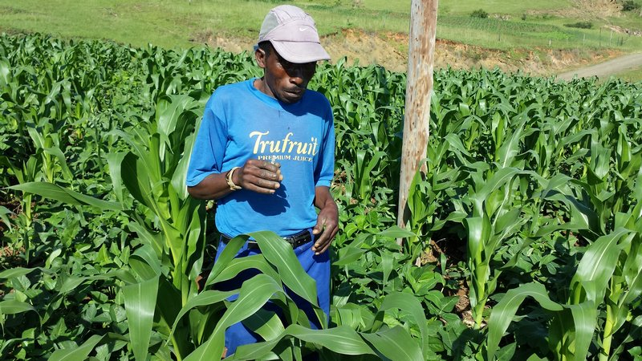 | Crust: Yes, Run-off-yes, Depth-10cm- control plot  Labour-2people  Germination and growth on control and trials very good. Intercropped trial much less weedy than mono crop blocks. Groundcover on trial very good (98%). On control plot there was 80% cover after 6 weeks. In the trial plots the maize-cowpea intercrops were visibly greener and larger than the maize in maize-beans intercrop mix.  Far left: Control; Germination and growth good.  Left: trial plot around Jan 2014. Very good growth and crop cover. |  |  |  |  |  |  | Beans 18 kg/ 200m²  Cowpeas  15 kg/ 200m²
2. Khulekani Dladla |  | m ²: | 1000m² . Hand hoe only. 400m² intercrop, maize, beans cowpeas. Rest planted to maize. Later entrant- Not enough LAN to top dress the whole plot. The one that was top dressed looks a lot better. Roundup pre and at planting. Dual Gold and decis forte at planting | 15%- dead weeds,  15% | 90%  Very few weeds, good crop cover 40% |  | 90%  90% |  | 90%  80% | 7.1  Trial  5.6 control | Beans1.99 t/ha  Cowpea  1 t/ha
 |  | 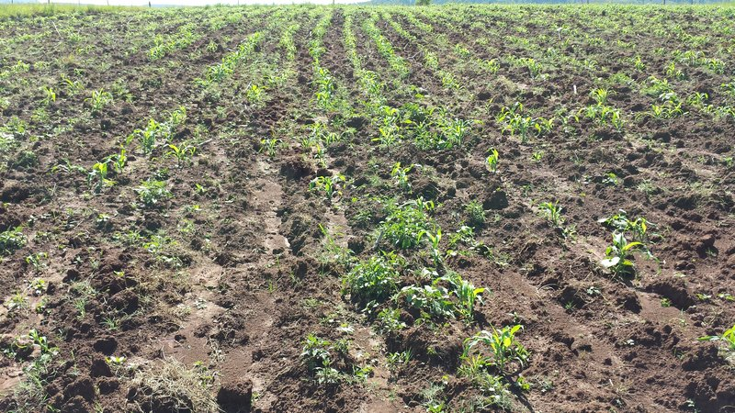 | 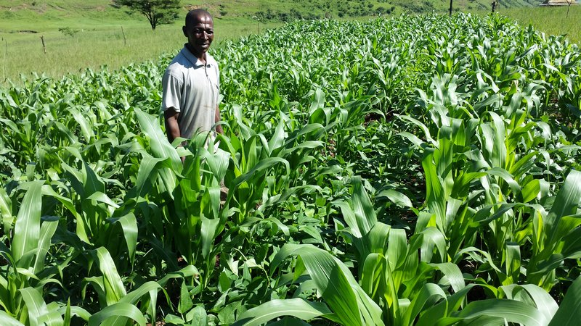 | Trial plot looked very good ito germination and growth as well as soil cover. Control plot ploughed with oxen had some of the more usual problems of weeds, and run-off.  Far Left: Control plot planted much later than the trial plot – issues with weeds and run-off  Left: trial plot in Jan 2014. Very good growth and crop cover. |  |  |  |  |  |  | Beans 19.9 kg/ 100m²  Cowpeas  10 kg/ 100m²
Manqoza Dladla  (discontinue) |  | ? m² - Planting done through the Dept of Agric. | 1000 m². Hand hoes and MBLI planter. 400m² intercrop, maize, beans cowpeas. Rest in single crop blocks. Roundup pre and at planting. Dual Gold and decis forte at planting
 |  |  |  | Plot not looking too good. Looks as if top dressing not done
3. Mrs Bangeni Dlamini  28°54.762´S  029°21.994´E |  | 46x142m=6532 m². Ploughed and planted by tractor. (2:3:1(25))2x50kg and 3x80kg manure. No of maize plants 270/row x 46. No pest control. Hand weeding x 1/season. | 1000 m² . 400m² intercrop, maize, beans cowpeas. 300m² beans, 300m² maize . Hand hoe only. 25kg MAP, 25 kg LAN- top dressing. Roundup pre and at planting. Dual Gold and decis forte at planting | 15%- dead weeds,  5% | 80%  Very few weeds, good crop cover  70% |  | 90%  90% |  | 90%  90% | 6.8  Trial  6.3  control | Beans733.5 kg/ha  Cowpea  3.0 t/ha
 |  | 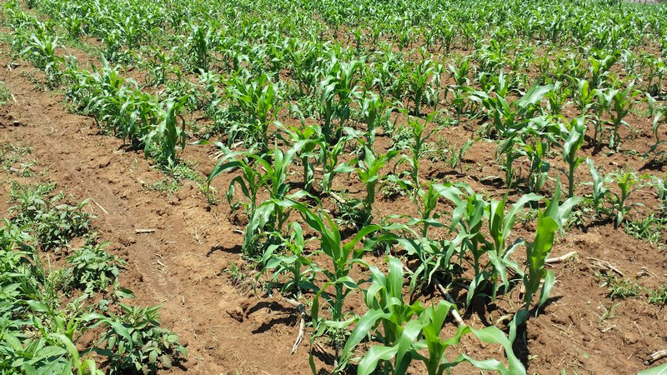 | 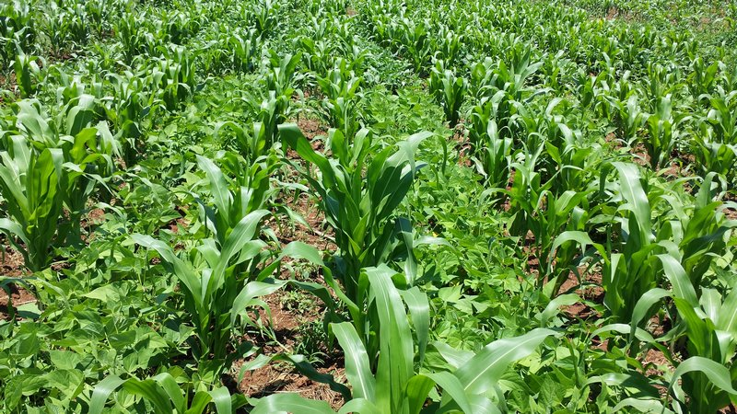 | Crust- yes, Run-off yes, depth 8cm (control)  Patchy germination in control plot, weeding an issue awa runoff. The trial had good cover (70%) after 6weeks and good growth. Very few pests. Control plot cover was 40% after 6 weeks.  Far left: Maize germination in control patchy and quite weedy (Feb 2014)  Left: Trial plot – good growth and cover by crop, reducing weeds. Few pests. |  |  |  |  |  |  | Beans: 29.34 kg/ 400m²  Cowpea 30.08 kg/ 100m²
4. Mrs Makethi Dladla  28°55.272´S  029°22.138´E |  | 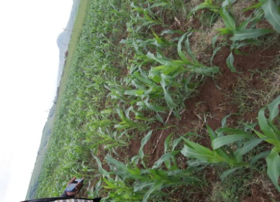  122x24m = 2928m² traditional maize seed. Ploughed with tractor, fertilizer (2:3:2(30) 1x50kg, manure (3x50kg) and seed spread at the same time. ~800 plantsx19 rows | 520m²:400m² of intercrop, 120m² beans. Roundup pre and at planting. Dual Gold and decis forte at planting. Weeding was not required. Crop cover good. Weeded twice by hand for few weeds present | 15%- dead weeds,  5% | 90%  Very few weeds, good crop cover  90% |  | 90%  90% | 90%  40% |  | 7.1  Trial  4.1  control | Beans236 kg/ha  Cowpea  422 kg/ha
 |  | 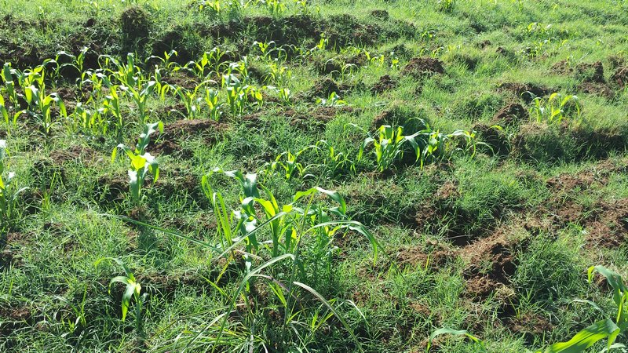 | 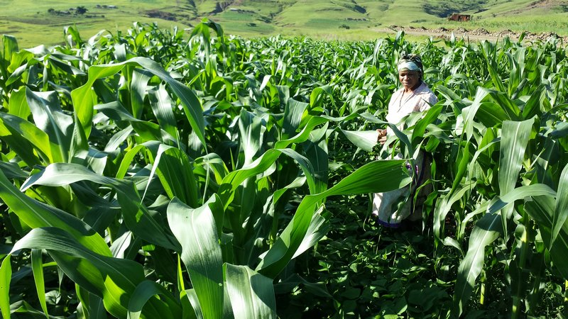 | Curst; yes, run-off-no, depth-10cm-control plot  Patchy germination in control plot, weeding and issue awa runoff. The trial had good cover and good growth. Very few pests. Cover on control plot 40% 6 wks after planting and trial was100%.  Far left: Maize germination in control patchy and quite weedy (Feb 2014)Lfar left top: The plot recovered somewhat after weeding in March 2014.  Left: Trial plot – good growth and cover by crop, reducing weeds. Few pests |  |  |  |  |  |  | Beans: 5.199 kg/ 220m²  Cowpea  4.422 kg/ 100m²
5. Mr Mtoleni Buthelezi |  | 1000m²MAP,PAN- 25kg,Topdressing LAN 50kg. Oxen drawn planter. Trad maize seed (3kg). 50mx12 rows, 120plants/row. Spacing 90cmx25cm | 700m²; 400m² of intercrop, 100m²beans, 200m² maize. Roundup pre and at planting. Dual Gold and decis forte at planting | 10%  0% | 75%  30% |  | 90%  90% |  | 80%  70% | 6.4trial  4.7 control | Beans495 kg/ha  Cowpea  390 kg/ha
 |  | 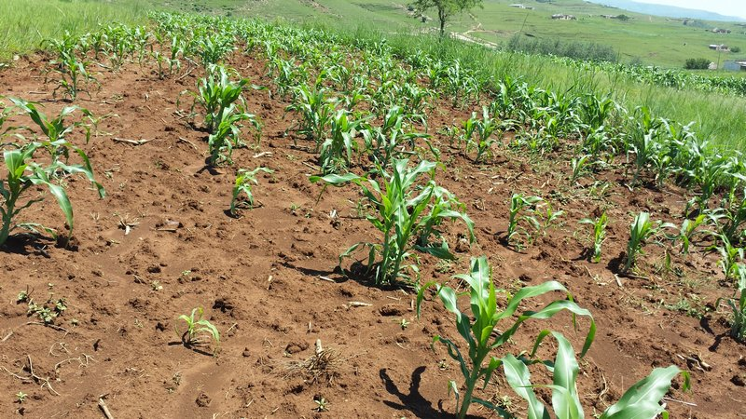 | 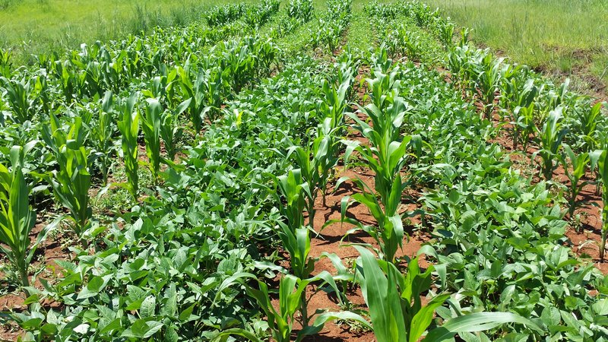 | Germination on control very patchy due to run off and on trial reasonably good, but still a bit patchy. Weed infestation on trial slightly high and cover of crop not as good as for other participants. Far left: The control plot is quite bare after weeding and run off damage is apparent  Left: The trial plot has provided reasonably good cover, but still some issues with weeds that are competing slightly |  |  |  |  |  |  | Beans: 9.894 kg/ 200m²  Cowpea  3.896 kg/ 100m²
6. Thulisile Hlongwane  28°55.651´S  029°22.492´E |  | 120x79m =9480m². Trad seed. Tractor for ploughing and planting. 1x50kg DNP, 5x80kg manure. 331plants/row x79 rows. | 900m²; 400m² intercrop. 300m²beans, 300m²mazie. 25kg MAP, 25 kg LAN- top dressing. Hand hoe only. Roundup pre and at planting. Dual Gold and Decis Forte at planting. And Decis Forte again at top dressing. 25 maize plants/rowx17rows. | 15%- dead weeds,  5% | 90%  Very few weeds, good crop cover  30% |  | 90%  90% |  | 90%  80% | 7.1  Trial  5.1  control | Beans293.4 kg/ha  Cowpea  1.34 t/ha
 |  | 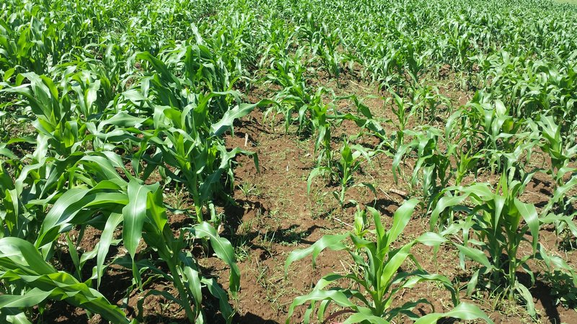 | 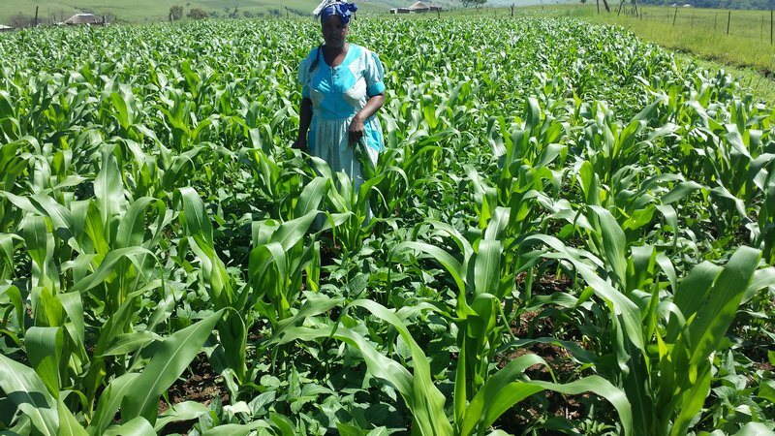 | Crust,yes, run-off-yes, depth,10cm- control plot  Very good cover on trial plot (98% ) 6 weeks after planting. Control cover at 6weeks was (80%) Weeding done well, by hand in both control and trial 1x during season around 3weeks after planting.  Far left: growth of control plot quite good, although the stand of the traditional maize is uneven.  Left: Growth of trial plot very good. |  |  |  |  |  |  | Beans: 11.736 kg/ 400m²  Cowpea  13.425 kg/ 100m²
7. Landiwe Nsele  28°54.696´S  29°22.066´E |  | 150x12m= 1800m². 1x50kg 2:3:2(25) and 2x80kg manure. Traditional seed.Tractor for ploughing and planting. 300plants per rowx10 rows. Stalkborer granules (effecto) | 1000m²; 400m² intercrop. 300m² maize, 200m² beans, 100m² cowpeas. Roundup pre and at planting. Dual Gold and decis forte at planting. 25kg MAP, 25 kg LAN- top dressing. Hand hoe only | 30%- dead weeds, maize stalks  10% |  | 70%  Very few weeds, good crop cover  40% | 90%  90% |  | 80%  70% | 6.7  Trial  5.2  control | Beans 1.25 t/ha  Cowpea  1.08 t/ha
 |  | 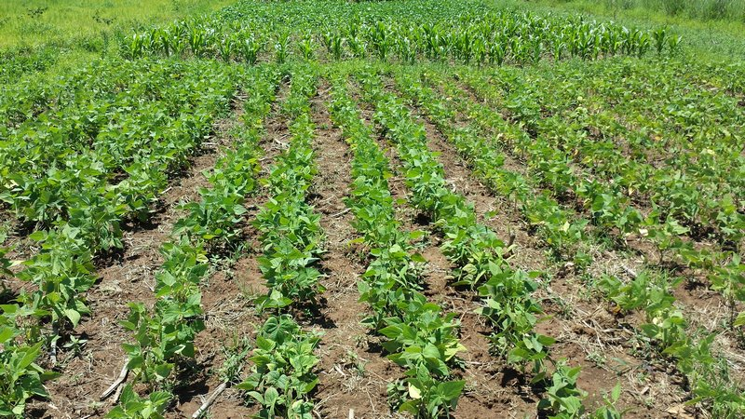 | 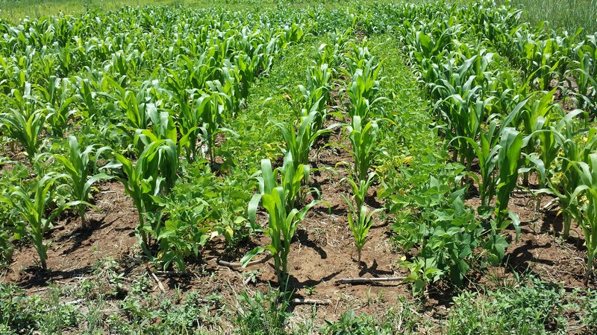 | Crust-yes, runoff-no, depth 8cm – control plot.  The cowpea maize intercrop gave better cover than the bean-maize (around 70%) cover at 7 weeks. Single crop cowpea as well gave good cover. Weeding done 3 weeks after planting for control and about 5 weeks after planting for trial. Took 6 days in total for 1 person.  Far left: sing block planting of beans for trial, with control plot maize in the background.  Left: Intercrop trial plot of maize and beans. Cover is better than for single crop plantings. |  |  |  |  |  |  | Beans: 37.64 kg/ 300m²  Cowpea 21.70 kg/ 200m²
8. Phasazile Sithebe  28°54.787´S  29°21.881´E |  | 137x34m=4658m². Tradtional seed.Tractor for ploughing and planting. LAN/KAN (28) 1x50kg. 310plants per row x 32 rows | 1000m²; 400m² intercrop. 200m² maize, beans and cowpeas resepctively. Roundup pre and at planting. Dual Gold and decis forte at planting. 25kg MAP, 25 kg LAN- top dressing. Hand hoe only. Plants per row (maize=39x16rows. | 30%- dead weeds, maize stalks  10% |  | 80%  Very few weeds, good crop cover  60% | 90%  90% |  | 85%  75% | 7.1  Trial  5.9  control | Beans 1.57 t/ha  Cowpea 566 kg/ha
 |  | 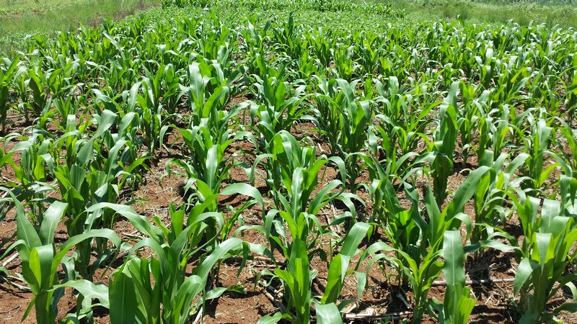 | 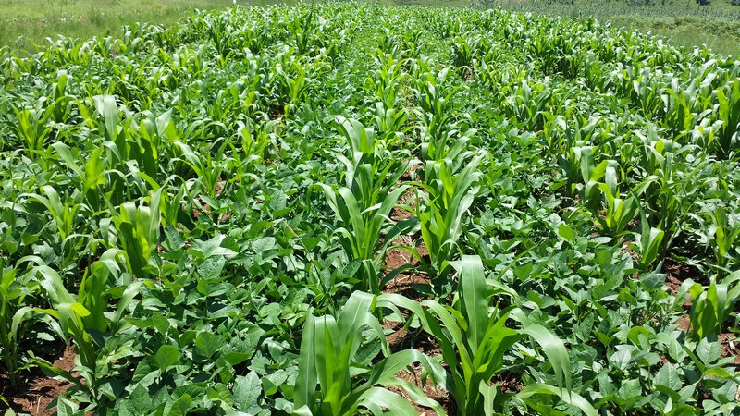 | Crust-yes, runoff-no, depth 5cm – control plot.  Good growth on both control (50%) on maize, 70% on beans) and trial plot (70% for intercrop) 5-6 weeks after planting. Wedding done early at 3-4 weeks after planting. |  |  |  |  |  |  | Beans: 47.21 kg/ 300m²  Cowpea 17 kg/ 300m²
9. Cuphile Buthelezi  28°55.055´S  029°22.081´E |  | 330mx17m= 5610m² 2.5 x 50kg manure and 1.5x 50 kgDAPfertilizer. Traditional seed. 560plants/ row x 15rows. Tractor for ploughing and planting. No herbicides or pesticides used.4 People required for labour. | 400m² intercrop. 10x10m blocks of maize(2), beans (x2), cowpeas. Roundup pre and at planting. Dual Gold and decis forte at planting. 25kg MAP, 25 kg LAN- top dressing. Hand hoetwo plots, MBLI planter, 2 plots. Plants per row (maize=17x12 rows) Decis forte sprayed again at top dressing 7-8 weeks after planting. | 15%- weeds, maize stalks  5% | 60%  Very few weeds, good crop cover  60% |  | 90%  80% |  | 75%  65% | 6  Trial  5.2  control | Beans908 kgt/ha  Cowpea  1.14 t/ha
 |  | 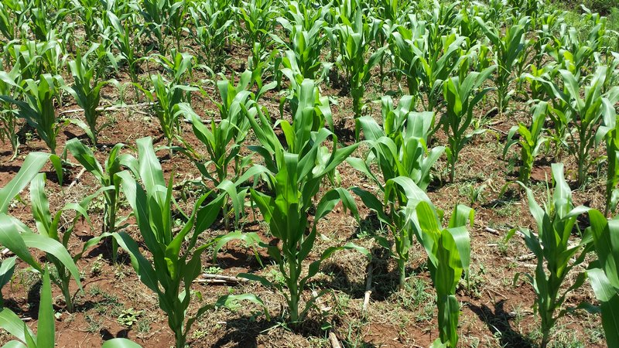 | 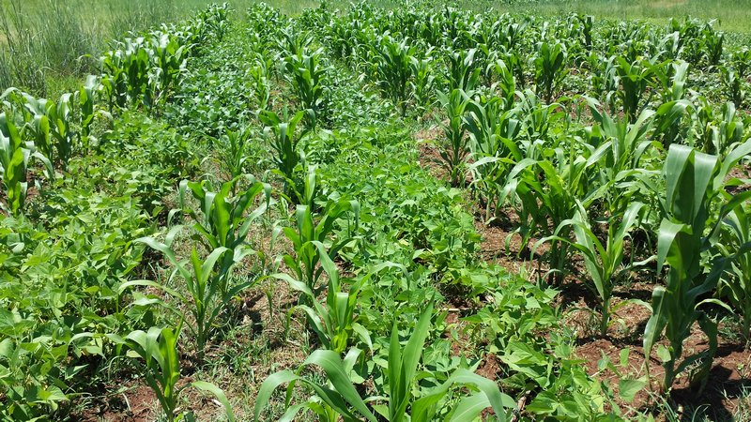 | Crust-yes, runoff-no, depth 20cm – control plot.  Weeding in trial and control done quite late at 8-9 weeks after planting. Weeding was very difficult on the trial plot as Cuphile has to do this by herself.  Far Left; the control plot maize stand was a little patchy- due to planting method and weed competition  Left; Weeds in the trial plot provided some difficulty and also limited the growth and cover of the maize and legume intercrops |  |  |  |  |  |  | 27.25 kg/ 300m²  Cowpea  22.83 kg/ 200m²
10. Cazile Zimba  28°55.585´S  029°22.679´E |  | 130x19m=2470m². 25 Kg MAP and 4 wheelbarrows manure. Local seed and hybrids. 225 plants per row x16rows for maize. | 400m² intercrop. 10x10m blocks of maize, beans (x2), cowpeas Roundup pre and at planting. Dual Gold and decis forte at planting. 25kg MAP, 25 kg LAN- top dressing. Hand hoe two plots, MBLI planter, 2 plots. Plants per row (maize=31.16 rows) Decis forte sprayed again at top dressing 7-8 weeks after planting | 15%- dead weeds, maize stalks  5% |  | 90%  Very few weeds, good crop cover  60% | 90%  80% |  | 90%  65% | 7.1  Trial  4.7  control
Crust-yes, runoff-no, depth 12cm – control plot.
Cover later in season for control plot of maize still not very good (30%), leading to the need for extensive weeding. Weeded once around 3-4 weeks after planting. Trial plot cover and growth was good.
11. Zamani Dladla  28°55.468´S  029°22.300´E |  | 49x21m=1029m². 3:2:3(30) 1x50kg , manure 1x50kg. Local maize seed. 83 plants/row x 19 rows. | 400m² intercrop. 10x10m blocks of maize, beans (x2), cowpeas Roundup pre and at planting. Dual Gold and decis forte at planting. 25kg MAP, 25 kg LAN- top dressing. Hand hoe two plots, MBLI planter, 2 plots. Plants per row (maize=40/ row x13 rows) Decis forte sprayed again at top dressing 7-8 weeks after planting | 15%- dead weeds, maize stalks  5% |  | 80%  Very few weeds, good crop cover  60% | 90%  80% |  | 90%  85% | 6.8  Trial  7.2  control | Beans1.72 t/ha  Cowpea  720 kg/ha
 |  |  |  | Crust-yes, runoff-yes, depth 10cm – control plot.  Control plot weeded once 3-4 weeks after planting. Stand and growth good due to early weeding |  |  |  |  |  |  | 17.159 kg/ 100m²  Cowpea  7.207kg/ 100m²

